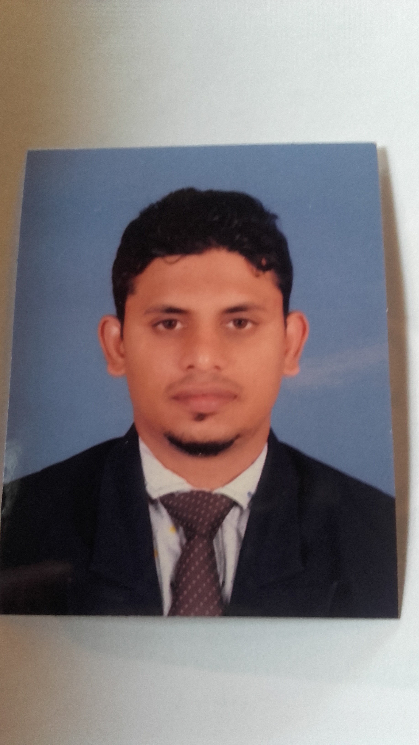

**CURRICULAM VITEA**

**Objective:** Seeking for the position as a service **Service** **Coordinator / Computer Operator/customer care call center, Customer service reception, Data Entry operator and supervisor in service**

**SUMMARY OF EXPERIENCE**

Over Four (6) years of experience in various firms, experience in Secretarial / Documentation field. Computer literate and well acquainted with office procedures, documentation, Data entry and filing system.

**PERSONAL INFORMATION**

Name in full : Raseen Mohamed fazeel Haq

Name with initials : R.M.Fazeel Haq

Permanent Address : 23A, 14th Cross Street, Spill Road, Puttalam

61300, Srilanka

Date of Birth : 29thAugust 1984

Age : 31

Civil Status : married

Sex : Male

Passport # : N1140821

Contact # : +94712569381

Religion : Islam

E-mail : rbfazeel@gmail.com

Language skills : English, Tamil, Sinhala, Hindi, Malayalam and Arabic

Driving license : Srilanka

**ACADEMIC QUALIFICATIONS**

• **General Certificate of Education GCE (O/L) and (A/L) @** *Zahira National College, Puttalam-61300,*

***COMPLETED ORDINARY LEVEL IN 2002***

***SUBJECT******GRADE***

*ISLAM B*

*TAMIL C*

*BUSINESS & ACCT C*

*MATHS C*

*ENGLISH C*

*SCIENCE S*

*SOCIAL STUDIES & HISTORY S*

*GEOGRAPHY S*

*HEALTH & PHYSICAL EDU S*

***COMPLETED ADVANCED LEVEL IN 2005***

***SUBJECT******GRADE***

*ISLAM B*

*GEOGRAPHY C*

*TAMIL S*

• **Diploma in English**

*British college of applied studies in Colombo (Srilanka) since April 2006 to July 2006*

**PROFESSIONAL QUALIFICATIONS**

• **Diploma in Computer Science**

Introduction to IT Windows XP

Microsoft Word Microsoft Excel

Microsoft PowerPoint Microsoft Access

Internet & e-mail Introduction to Hardware

• **Diploma in Computer Science ”at Kuwaiti Technology” at Colombo**

**Sri-Lanka**

• **Diploma in computerized accounting.** Accpac, Quick-book Pro, Tally & Myob

•  **Certificate in information technology "@ British college of applied study.**

•  **Diploma in Computer Hard ware engineering with ne working” @Turnkey.**

Introduction to IT Windows XP

Office XP Internet & e-mail Introduction to Hardware Introduction to Flash Data Communication Virus Protection Introduction to VB

Assembler or upgrade own computer

Formatting

Troubleshoot &repair all kind of PCS master software installation.

Pc configuration Networking of computer.

Be a specialist in pc.

**Professional Experience:**

**Computer Instructor** at CBS Srilanka (From Jan-08 to Mar-09)

• Computer instruction - primarily commonly used business programs (Word, Excel, Tally, accpect, myob, Access, PowerPoint, Windows etc.) generally for business people.

• To meet every class session promptly and ready for that sessions instruction.

• Coordination and implementation of instruction in an orderly and professional manner.

•             Assist Administrative Support by answering the telephone, intercepts

Telephone calls, taking and reporting messages.

**Data Entry Operator – At SYNTAX PVT LIMILTED Srilanka** (From Mar-06 to Dec-07)

• Responsibility includes logging all incoming /out going correspondence & documents in database system.

• Preparing Invoices, quotations & inventories.

• Maintaining all incoming / outgoing Calls & faxes.

• Updating of master Control Index on daily / weekly basis.

• Typing all correspondences, delivering and distributing them.

• Handling all local purchasing and petty cash.

• Handling DHL mails (Outgoing / Incoming).

**I have worked with DEMB (Distance Education modernization project) Sri Lanka**(From Sep-05 to Feb-06)

* Typing all correspondences, delivering and distributing them.
* Electronically log all in/out correspondences in the database system and file them in well-established filling system.
* Mails distributing from contractors to client.
* Handling all local purchasing and petty cash.
* Updating of master Control Index on daily / weekly basis.
* Handling all office personnel vacation schedule and time sheets.
* primarily commonly used business programs (Word, Excel, Tally, Access, PowerPoint, Windows etc.) generally for business people.

**Service Centre coordinator – (At jumbo video home& Electronic Centre Audio & Video Centre) LG in Qatar** (From july22-09 )

**Tel: +9744410060 (5Lines) Ext:232**

**Jumbo Fariq Naser : +9744318512**

**Home Appliances LG Service Centre.**

**Industrial Area st.No:36-Direct Lines:+9744600296-4604217-4365454**

**Fax:+9744501772-4437876 C.R.No:9200-P.O.Box:4668-DOHA QATAR.**

• Responsibility includes logging all incoming /outgoing correspondence & documents in database system.

• Preparing Invoices, quotations & inventories.

• Maintaining all incoming / outgoing Calls & faxes.

• updating of master Control Index on daily / weekly basis.

• typing all correspondences, delivering and distributing them.

• Handling all local purchasing and petty cash.

• Handling DHL mails (Outgoing / Incoming).

* Typing all correspondences, delivering & receiving all Appliances.
* Typing All Supervisor Remarks & Status.
* Primarily commonly used business programs (Word, Excel, Access, PowerPoint, Windows etc.) generally for business people.
* Responsibility of customer calls
* Spare part order and tools inquiry
* Participated in the management and spacialits skills devolopment programe service: 26th of April 2012 (**CUSTOMER CARE & AFTER SALES SERVICE)**
* Emergency calls handling
* 2013 LG MEA service performance award “High merit Distributor”
* Best service company award for the year 2012
* In recognition of Exeptional performance during the year 2013
* In recognition me attendance fo thr **MOT** training held at the traning hall, Doha Qatar. **Conducted on 12th Nov-12 to 14th Nov-12**
* Summer scheme promo awarded- **RUNNER-UP 2014**
* For participation in “**Care & delight**” service workshop conducted at the **LG – JUMBO TRAINING CENTRE- DOHA** on 26th April-12

**EXTRA CURRICULLAM**

* I have participated school sports competition.
* I have participated Sri Lanka football league tournament.
* I have participated Islamic competition.
* I have participated district competition.
* I have participated youth camp program
* I have participated Care and delight program in DOHA QATAR in 2012
* I have participated MOT training in DOHA QATAR

**NOT RELATED REFEREES:**

Mr. Yakoob Mr. Hizam

Principal Justice of peace

Zahira National College Puttalam

Puttalam +94774144432

+94322265473

*I do hereby declare that the information given above is true and correct to the best of my knowledge.*

…………………………………………. …………………………………………………

**Date** **Signature**